**Basic Program Structure**

**3.1 Flowchart and Pseudocode**

Finding the Nearer Coffee Shop

Design an algorithm to find the nearer coffee shop

Top-down stepwise

1. Decomposition

- Break into smaller subproblems

2. Stepwise refinement

1. Calculate the distance to location

2. Find the nearer location

Flowchart Symbols

Oval – Start and End

Parallelogram – Input and Output

Rectange – Process (Addition)

Diamond – Decision (leading to two flow lines)

Flow Lines – Next step

Pseudocode common words

IF, ELSE, WHILE

READ, PRINT, INIT, COMPUTE, ADD, SUBTRACT

* One statement per line
* Capitalize keywords
* Indent to show Hierarchy
* End multiline structures
* Independent of programming language

Algorithms are used to describe the solution to a problem.

* They are language-independent.
* They cannot be understood by computers.

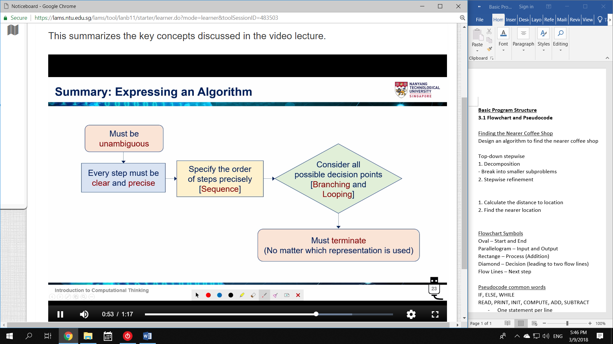

**3.2 Data Type, Variable**

1. Count the blocks of the horizontal movement

2. Count the blocks of the vertical movement

We need temporary data storage.

* store in variables

Variable

We give names (abstraction).

* Names are easier to remember

Variables have

1. Name

2. Value

Expressions: are combinations of values, including operators.

Assignment Operators: =

* Assign x a value 🡪 x = 24
* The statement does not mean x equals 24, it has just assigned x the value 24
* After the assignment, x is now == 24

eg.

x = x + 7 🡪 recall x, add 7 to it, assign to x.

Integer: Whole numbers

Float: Real numbers (fractions)

Arithmetic Operators: Mathematical function that takes operands.

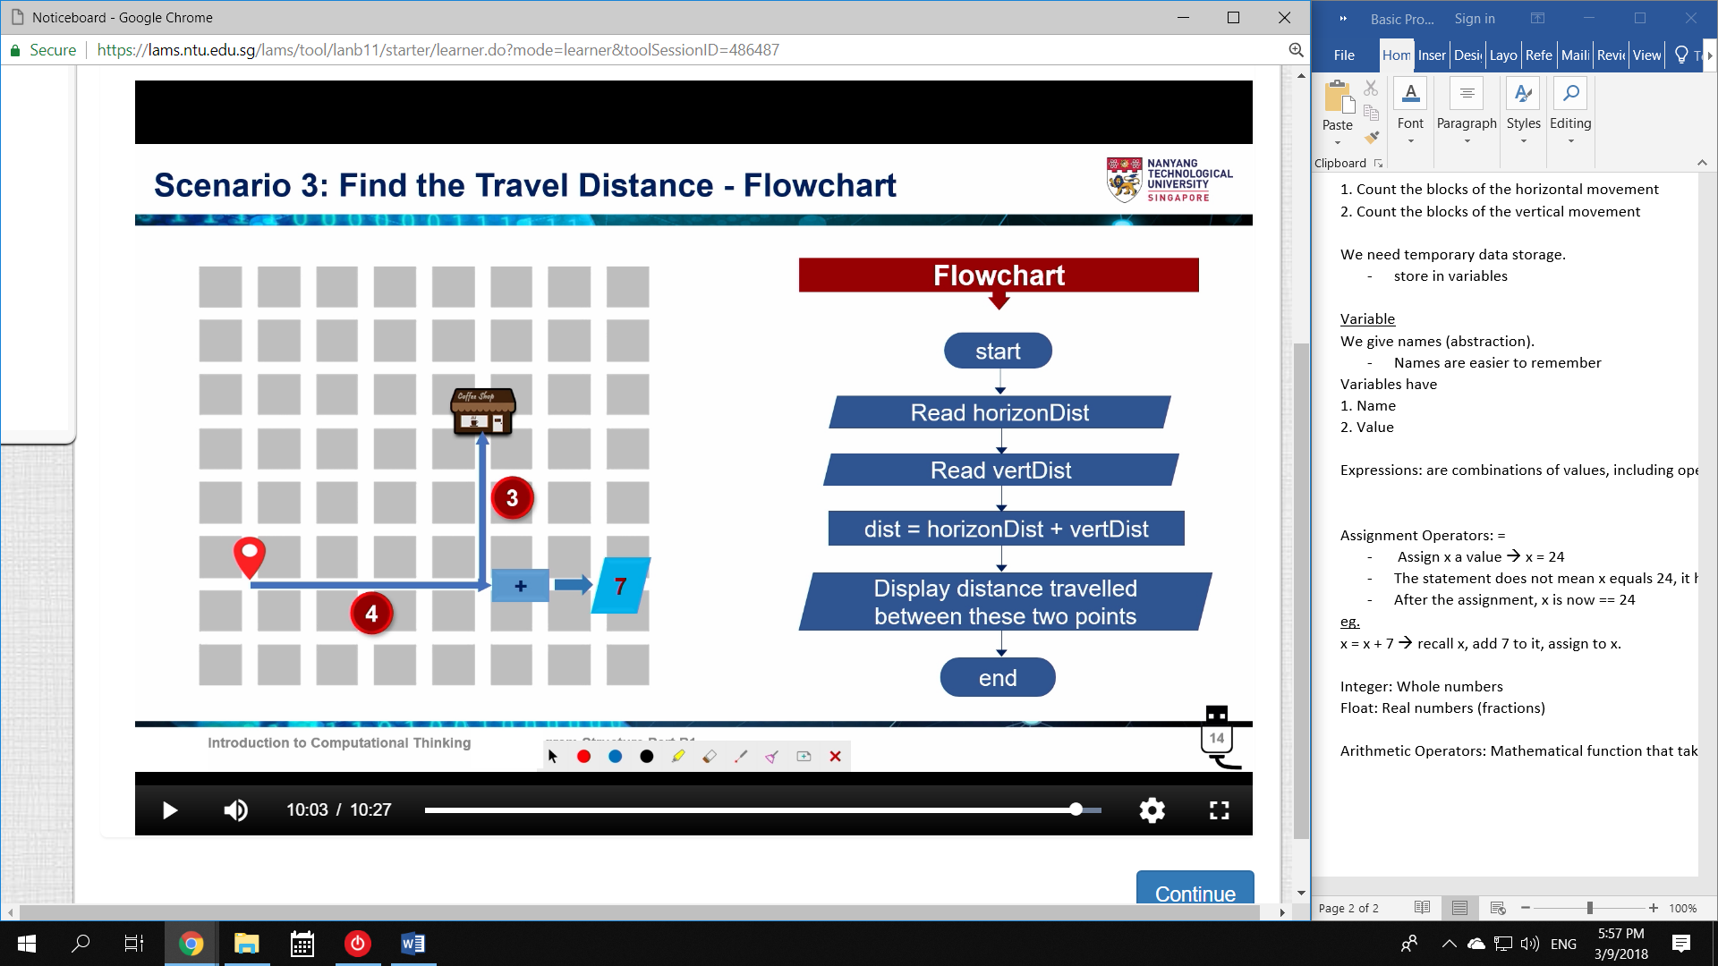

**3.3 Python**

Identifiers

a-z A-Z = 2*26 = 52 characters

‘_’ underscore = 1 character

0-9 numbers = 10 characters

Total: 63 characters

Cannot start with numbers

Cannot start with symbols $#&*

Cannot use keywords:

* def
* elif
* break
* try
* continue
* assert
* class

Variables can be

* Stored
* Retrieved
* Modified

Variables can be overriden.

Python uses Duck-typing

type() 🡪 type of variable

Python does not have variable declaration

Type of value determines type of variable

Reassignment changes type.

input() takes input from user

Add message with print()

